

Name: Abdulrahman Alawadhi PRN: 25070122008
Branch: CSE
Semester: 3
Subject: Programming with Java

ASSIGNMENT No.: 4
TITLE: :Develop a Java application demonstrating the use of wrapper classes for conversion between primitive data types and objects, and performing basic operations on wrapped values.

Problem Statement:

Develop a Java application demonstrating the use of wrapper classes for conversion between primitive data types and objects, and performing basic operations on wrapped values.

Learning Objectives:

To perform conversion between primitive data types and wrapper objects using Java wrapper classes.

Theory:

Wrapper classes are predefined classes that encapsulate primitive data types into objects. Java provides wrapper classes such as Integer, Double, Character, and Boolean for every primitive type. They support autoboxing, unboxing, parsing, and conversion methods. Wrapper classes are widely used in Java Collections Framework and when object representation of primitive values is required.

Outcomes:

Wrapper classes in Java (Integer, Double, Character, Boolean, etc.) allow primitive data types to be treated as objects. This experiment demonstrated how to convert primitive values into their corresponding wrapper objects (boxing) and back into primitives (unboxing), how to convert String input into usable numeric types using methods like parseInt() and parseDouble(), and how wrapper class methods can be used to perform comparisons and basic operations on wrapped values — concepts essential for working with Java Collections and handling real-world user input.

Conclusion:

This experiment demonstrated the use of wrapper classes to convert between primitive data types and objects. Methods like parseInt() and parseDouble() converted String input into usable numbers, while compareTo() enabled validation, showing how wrapper classes support real-world data handling in Java.

Exercise:

- Create a program to convert student marks from String format to Integer and calculate total marks.

class Student{

String name;
String mark1Str, mark2Str, mark3Str; Student(String n, String m1, String m2, String m3){
name = n; mark1Str = m1; mark2Str = m2; mark3Str = m3;
}

void calculateTotal(){
int mark1 = Integer.parseInt(mark1Str); int mark2 = Integer.parseInt(mark2Str); int mark3 = Integer.parseInt(mark3Str);
int total = mark1 + mark2 + mark3;
double average = total/3.0;

System.out.println("Name: " + name);
System.out.println("Marks: " + mark1 + ", " + mark2 + ", " + mark3); System.out.println("Total: " + total);
System.out.println("Average: " + average);
}

public class JAVA_EXP_3{
public static void main(String[] args){
Student s1 = new Student("Abdulrahman","65","80","64"); s1.calculateTotal();
}
}

}

Output:
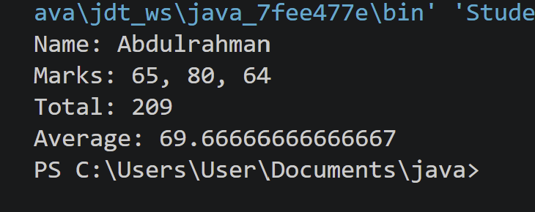

- Develop an Employee Payroll System that accepts employee IDs, basic salary, and bonus
amounts from the user. Convert the entered values into wrapper objects and perform validation operations to ensure valid salary values before calculating the net salary.

class Employee{ String empId;
Double basicSalary; Double bonus;

Employee(String id, String salaryStr, String bonusStr){ empId = id;
basicSalary = Double.parseDouble(salaryStr); bonus = Double.parseDouble(bonusStr);
}
void calculateNetSalary(){ if(basicSalary.compareTo(0.0) <= 0){
System.out.println("Invalid salary for Employee ID: " + empId);
return;

Input:
}
if(bonus.compareTo(0.0) < 0){
System.out.println("Invalid bonus for Employee ID: " + empId);
return;
}

double netSalary = basicSalary + bonus;

System.out.println("Employee ID: " + empId); System.out.println(" Salary: " + basicSalary); System.out.println("Bonus: " + bonus); System.out.println("Net Salary: " + netSalary);
}
}

public class JAVA_EXP_3{
public static void main(String[] args){
Employee e1 = new Employee("A008", "35000", "10000"); e1.calculateNetSalary();

System.out.println();

Employee e2 = new Employee("A015", "-200", "5000"); e2.calculateNetSalary();
}
}

Output:
